

**ASSIGNMENT 1**

[Design a **UP/DOWN DECADE COUNTER** using **J-K flip flops**]



**NAME: ROHIT SADHU**

**ROLL NO.: 002010501074**



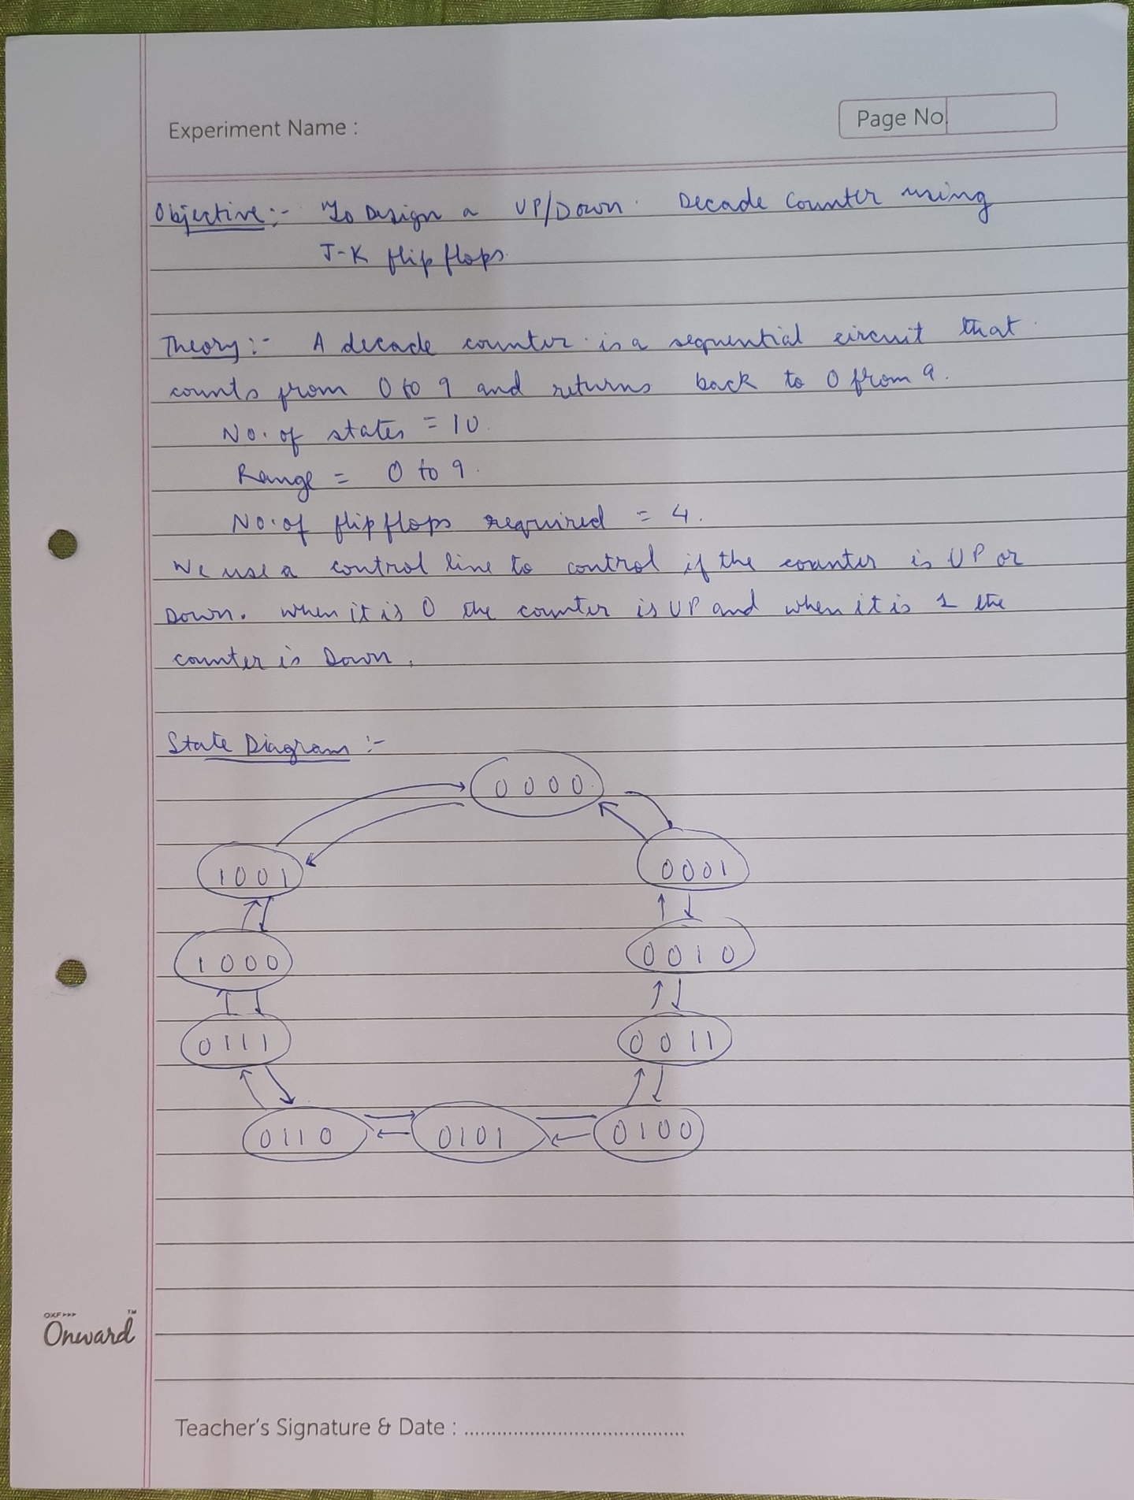

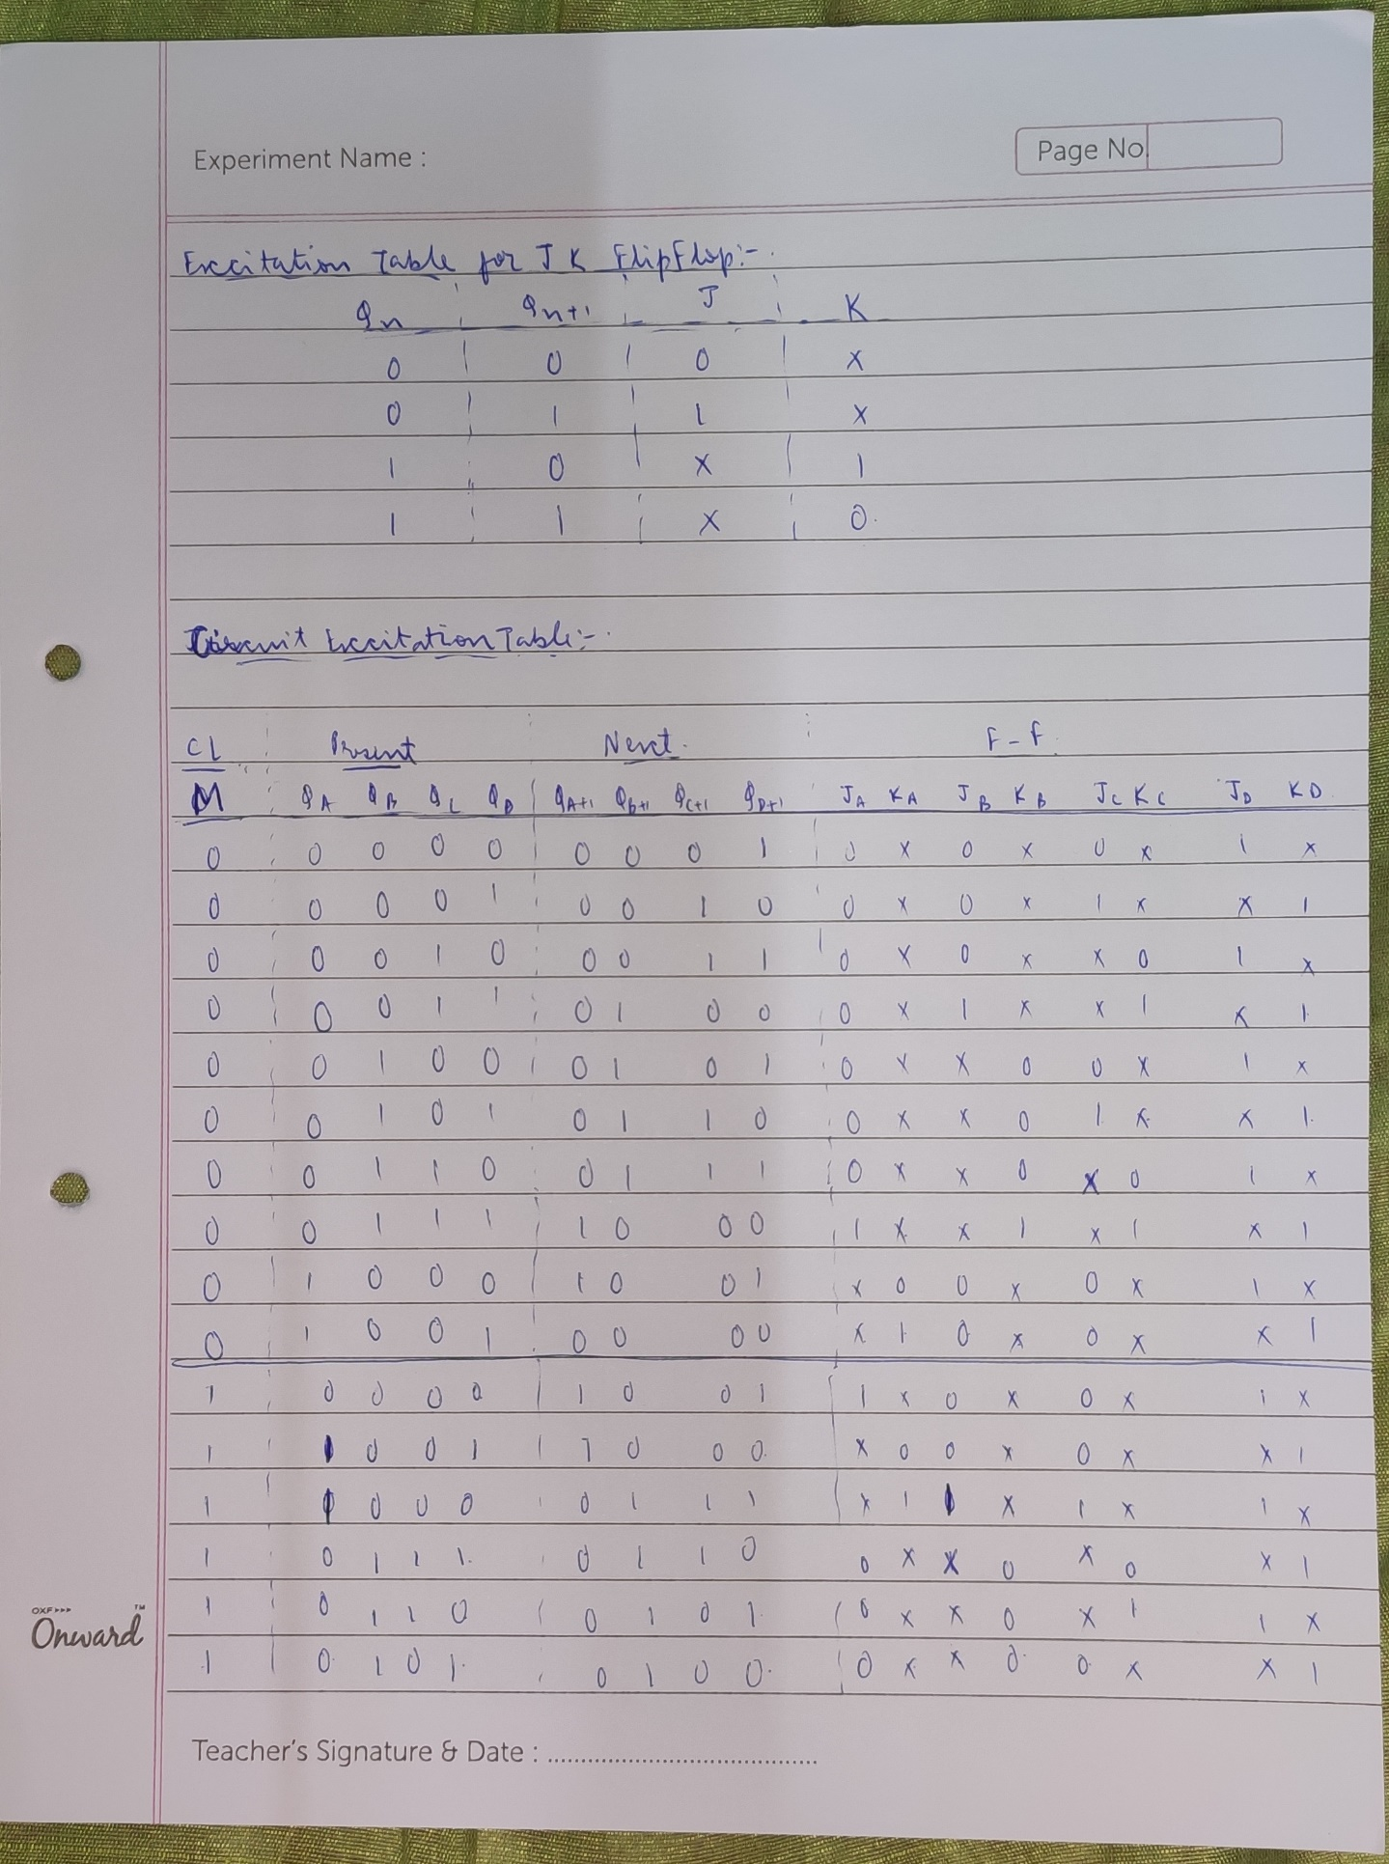

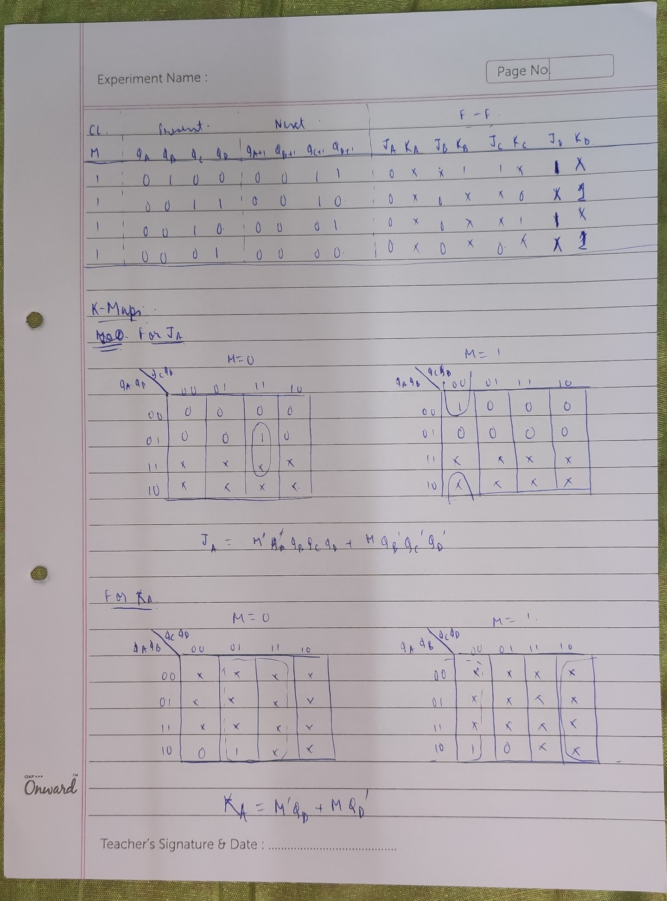

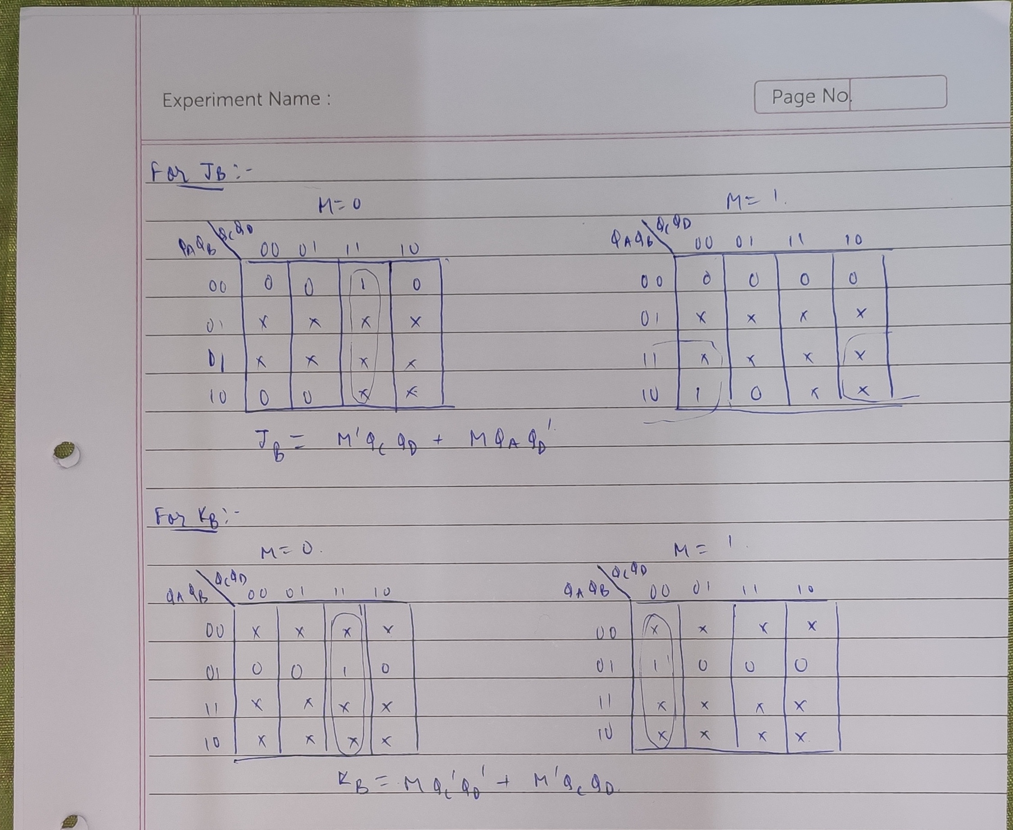

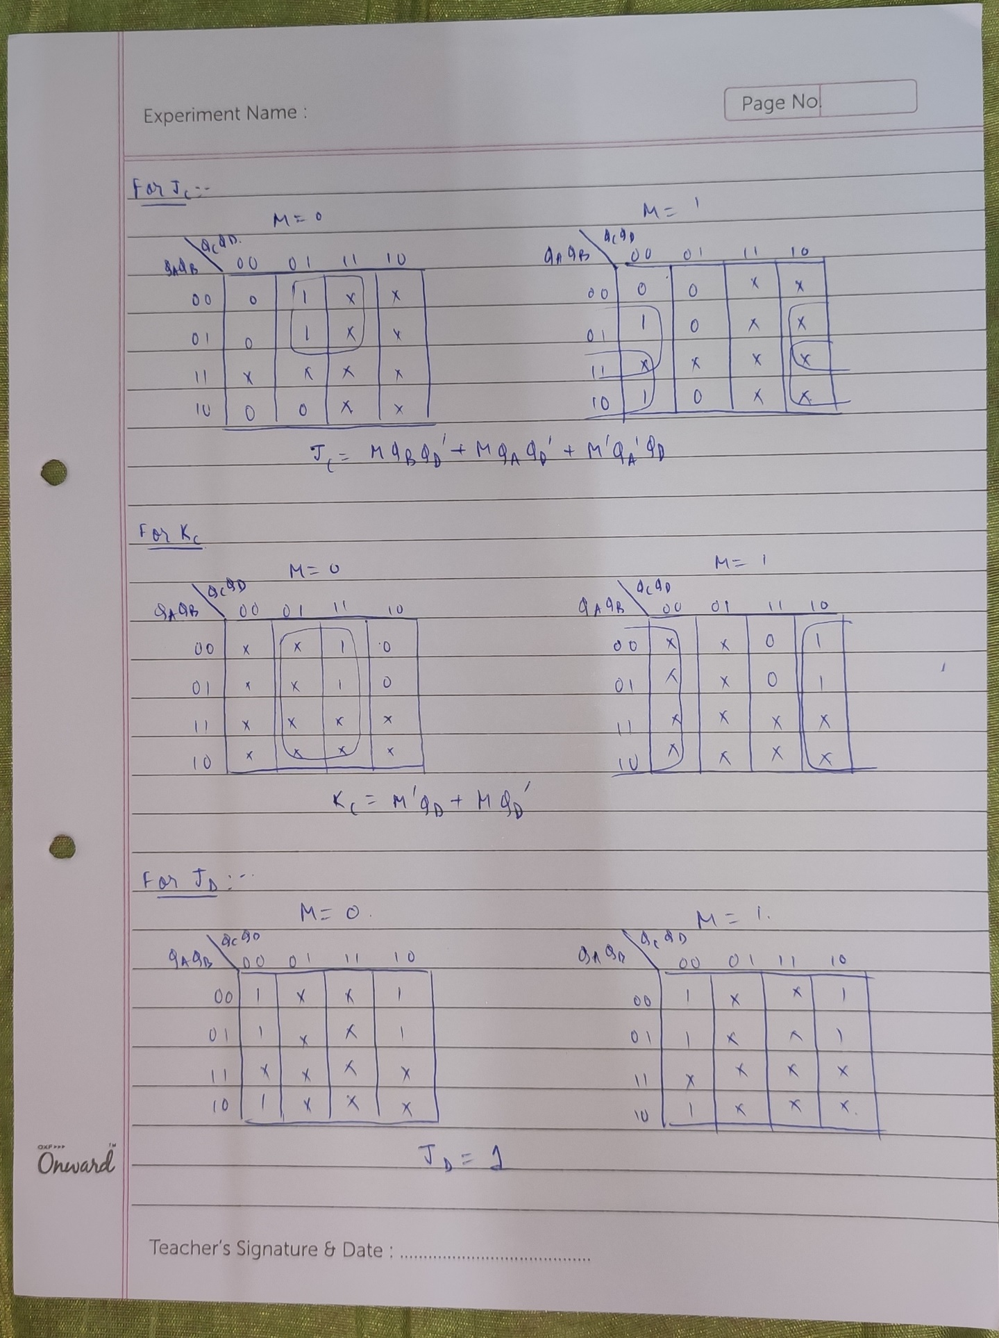

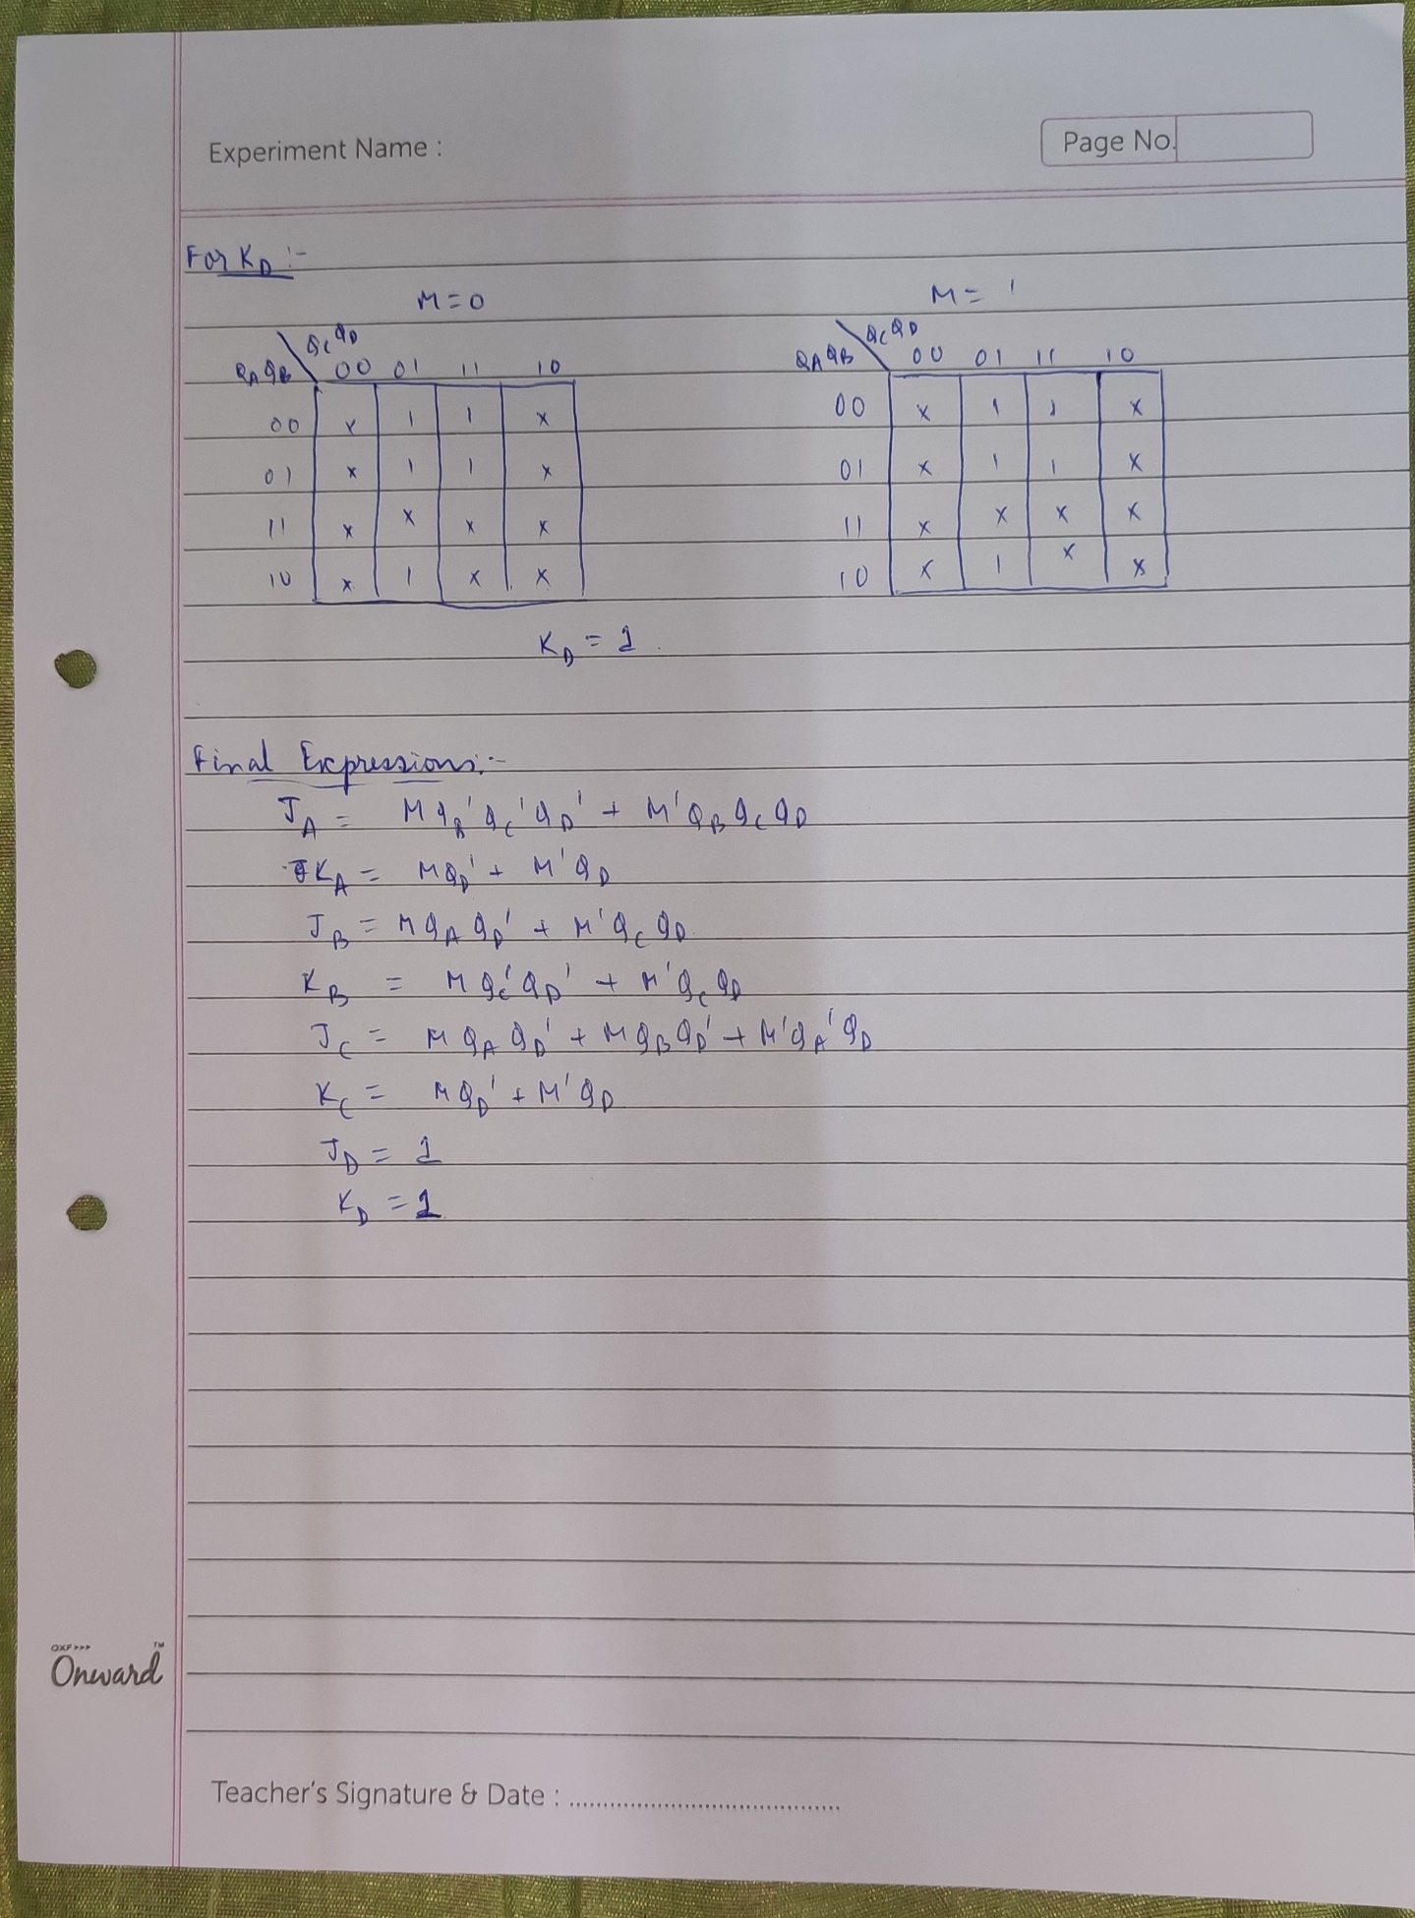

**CIRCUIT DIAGRAM:**

